Project Design Report

Project Category：Web Programming Project

Project Title：An online jersey shop Website

College: College of Computer Science

Major: Computer Science and Technology

Class: 1951520109

Student ID: 195152010907

Student Name: 艾博

Supervisor: Yanju Dong

Completion Date: Dec.31, 2021

|  |  |  |  |  |  |  |
| --- | --- | --- | --- | --- | --- | --- |
| **Shenyang Aerospace University** | | | | | | |
| **Task Specification for Project** | | | | | | |
| **Project Name** | Web Programming Project | | | | **Major** | Computer Science &  Technology |
| **Student Name** | 艾博 | | **Class**  **ID** | 1951520109 | **Student ID** | 195152010907 |
| **Project Title** | An online jersey Shop Website | | | | | |
| **Date** | **From** Dec. 13, 2021 **To**  Dec. 26, 2021 | | | | | |
| **Contents and Requirements** | | | | | | |
| Design and develop a small website for the shop.  **Design Requirements:**   * The link menu includes Homepage, About us, Service/Goods, Contact us, Login, Sign up, Logout. * Have 2-layer web directory at least, be around 18 pages in size. * All images should be optimized for the web. * Use CSS for page presentation (background images, all aspects of fonts, colors and, where possible, layout) * Demonstrate a 2-column or 3-column layout on at least one page (or something that requires you to practice page layout with CSS). * Include a shop logo and a site navigation that is just a simple list with some great style. * Include a simple contact form styled appropriately for the site (even though the form may not yet do anything). * If possible, a table used to display tabular data, such as a product list or fees and charges table. * Have a complete linked structure and consistence in page style such as color, background, font, and layout. * Includes the login and registration (sign up) page. The registered users can login to their account. And the registration can be done by following the sign up link. * Form Validation should be done in Login and registration (sign up) page with JavaScript. * Write the project report in accordance with the specification of course design report. | | | | | | |
| **Teacher(Signature)** | |  | | | Date |  |
| **Student(Signature)** | |  | | | Date |  |

**Contents**

Problem Specification 1

Website Design 1

Development Software 1

Website Structure Diagram 1

Document List 2

Website Page Screenshot 2

Analysis and Conclusions 3

References 4

Appendix A: Source Code 4

# Project Assignment Specification

The job to be done is to Design and Develop a small Online Jersey Store that will be selling Sport Jersey online, my store will be having different kinds of Jersey it will Soccer Jersey,Basketball Jersey,Baseball Jersey and Football Jersey.

This website will have also have:

1. The link menu includes Homepage, About us, Service/Goods, Contact us, Login, Sign up, Logout.

2. Have 3-layer web directory at least, be around 18 pages in size

3. All images will be optimized for the web.

4. CSS will be used for page presentation (background images, all aspects of fonts, colors and, where possible, layout)

5. The website will include a shop logo and a site navigation that is just a simple list with some great style.

6. Include a simple contact form styled appropriately for the site (even though the form may not yet do anything).

7.If possible, a table used to display tabular data, such as a product list or fees and charges table.

8.Have a complete linked structure and consistence in page style such as color, background, font, and layout.

9.Includes the login and registration (sign up) page. The registered users can login to their account. And the registration can be done by following the sign up link.

10.Form Validation will be done in Login and registration (sign up) page with JavaScript.

**Website Design**

## Development Software

Table: Development Software Table.

|  |  |  |  |
| --- | --- | --- | --- |
| **NO.** | **Software** | **Version** | **Purpose** |
| 1. | Visual studio | Version 17.0.3 | Write HTML page codes. |
| 2. | Adobe Photoshop | Version  23.0.2 | To design my project Logo and modify some images. |
| 3. | Google Chrome | 96.0.4664.104 | To run my and text my work |
| 4. | Visual Studio | Version 17.0.3 | To write and executed HTML, CSS and Javascript code |

## Website Structure Diagram

A website is the entire site, every page, and every process that goes on in the background, coming together to create an online presentation. A small website may have a simple structure while a large website may have a structure so complex you need a tour guide. This is our Website Structure show in Figure 1.

Home

Basketball

Sign Up

About

Contact

Football

Baseball

Soccer

SignIn

Figure 1: Website structure diagram

## Document List

List the document and its purpose used in the project.

Table 2: Document Table.

|  |  |  |
| --- | --- | --- |
| **NO.** | **Document** | **Purpose** |
| 1. | home.html | The homepage of the website |
| 2. | About us.html | The goal of the website |
| 3. | Contact us.html | Contact of our website in case of any emergency |
| 4. | login.html | To use your information you registered with to enter to our website. |
| 5. | signup.html | To register your information to be able to make an account. |
| 6. | jerseystore.css | Css codes for page representation. |
| 7. | Basketball.html | Display all basketball jersey in the store |
| 8. | Baseball.html | Display all baseball jersey in the store |
| 9. | Football.html | Display all the football jersey in the store |
| 10. | Soccer.html | Display all the soccer jersey in the store |
| 11. | table | Display the website items discount |

# Website Page Screenshot

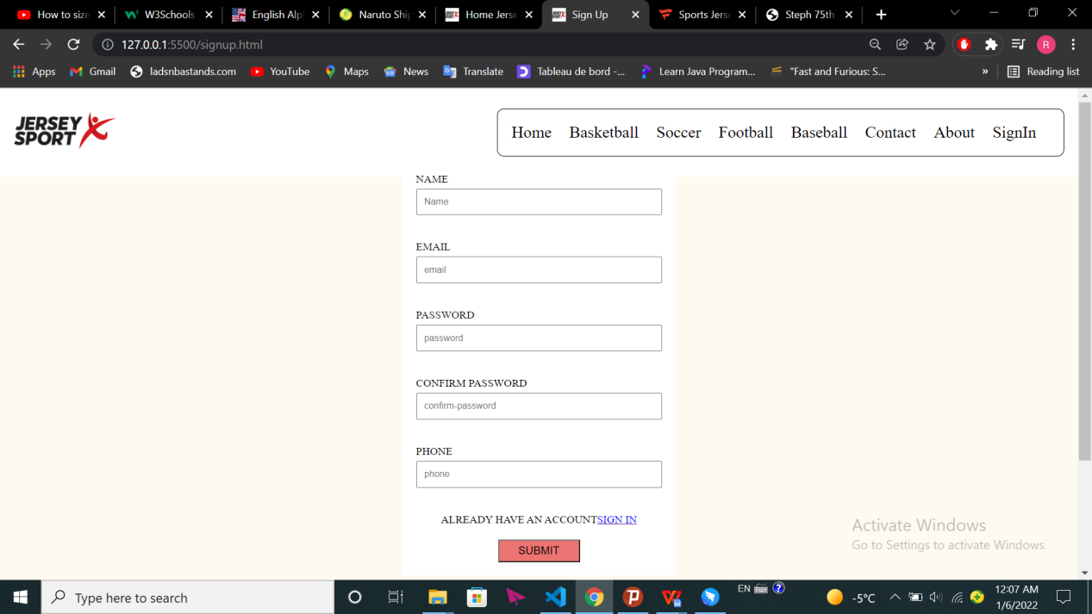

Figure 1: The sample of sign up page

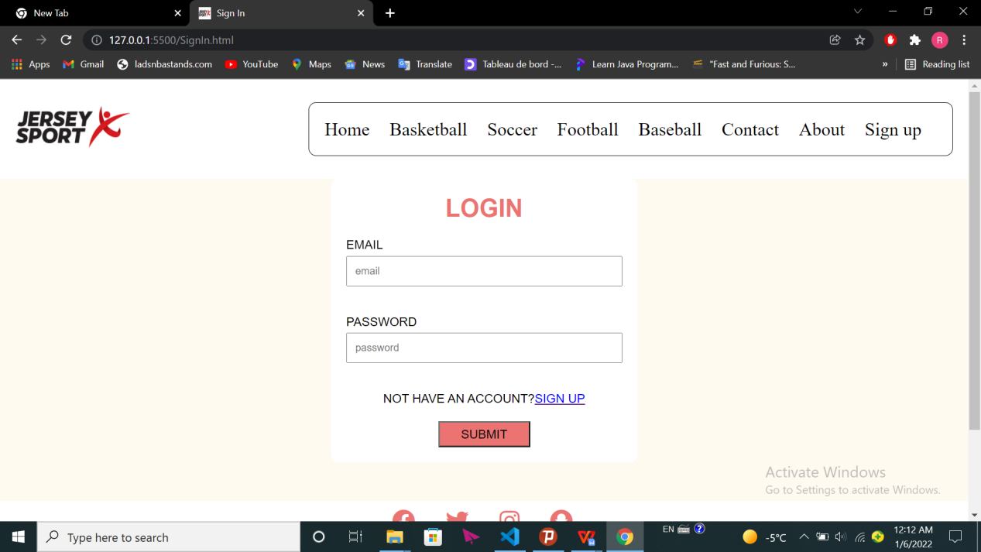

Fig2: The sample of log in page

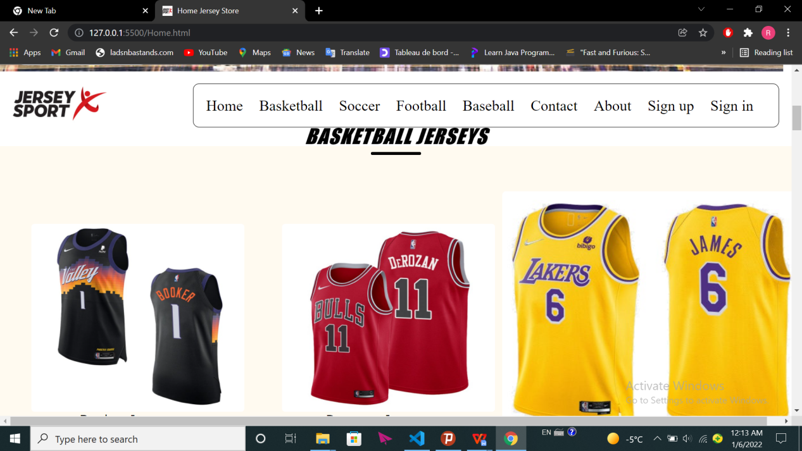

Fig3: The sample of homepage

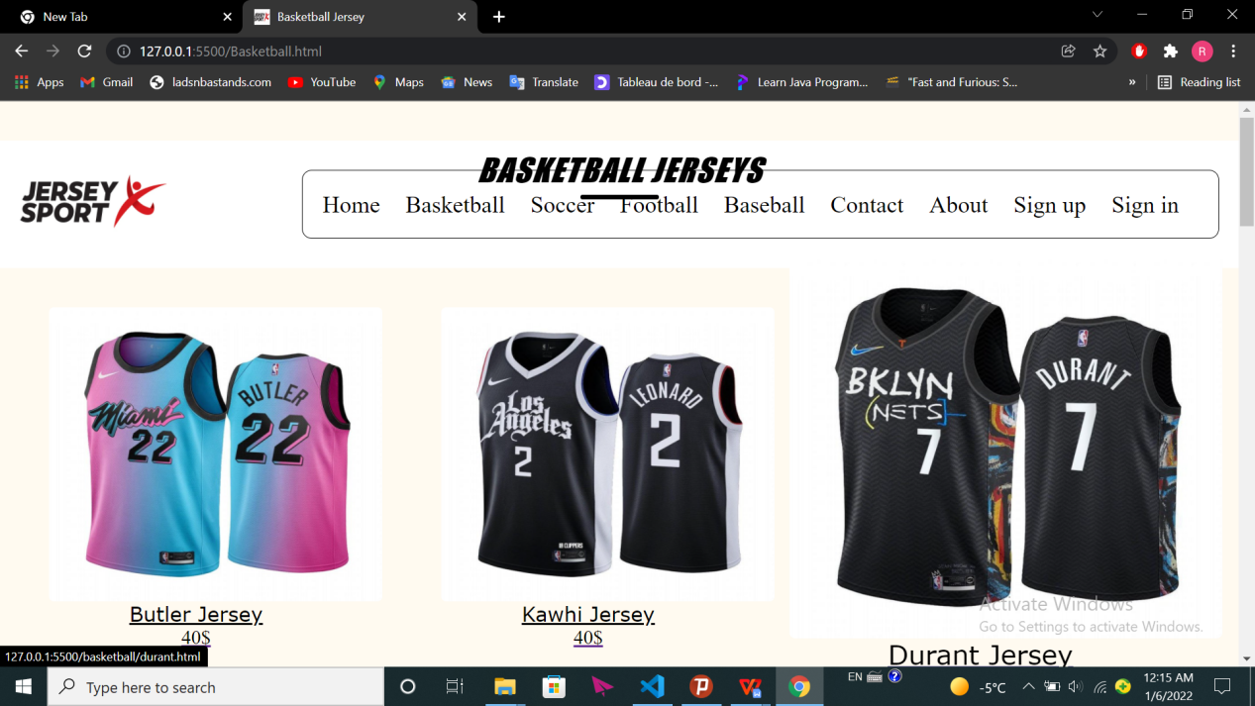

Fig4:The sample of basketball page

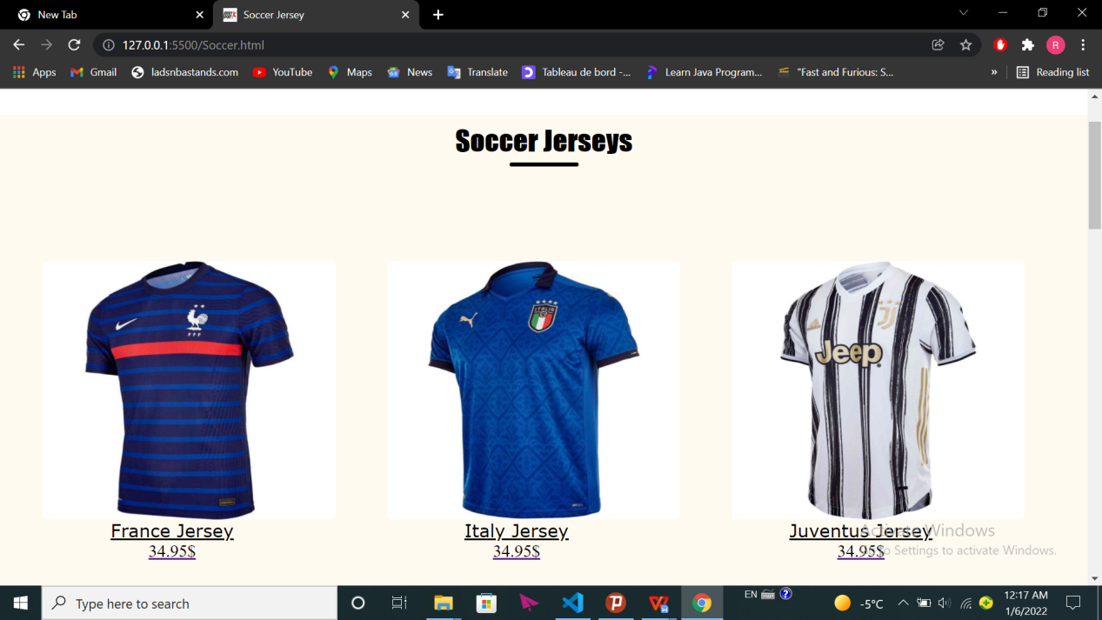

Fig5:The sample of soccer page

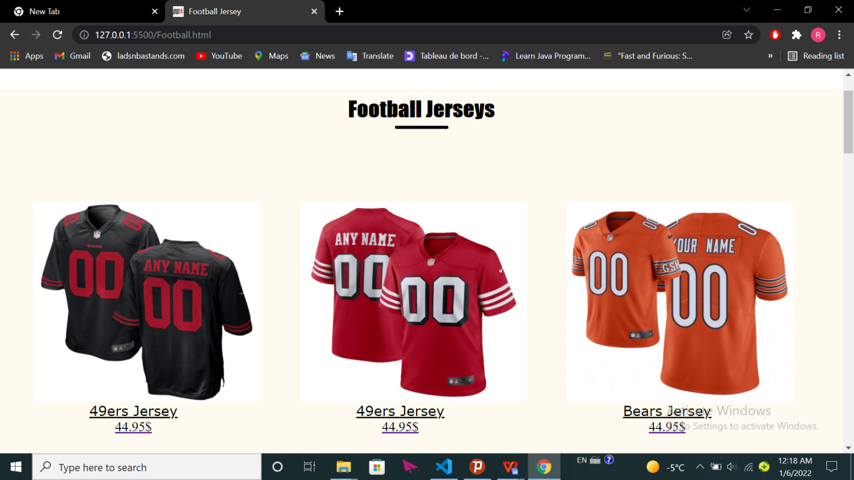

Fig6:The sample of football page

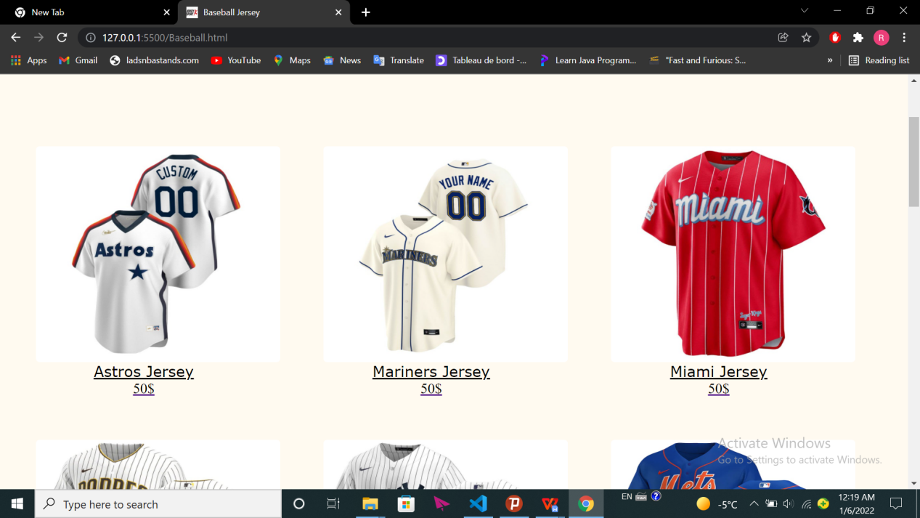

Fig7:The sample of baseball page

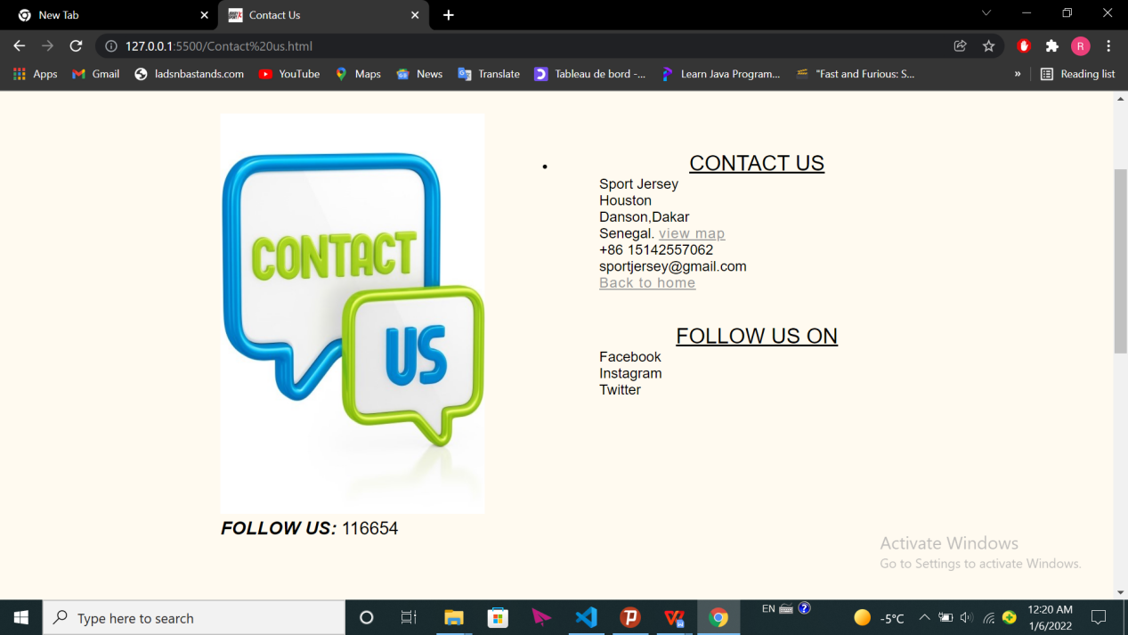

Fig8:Contact us page

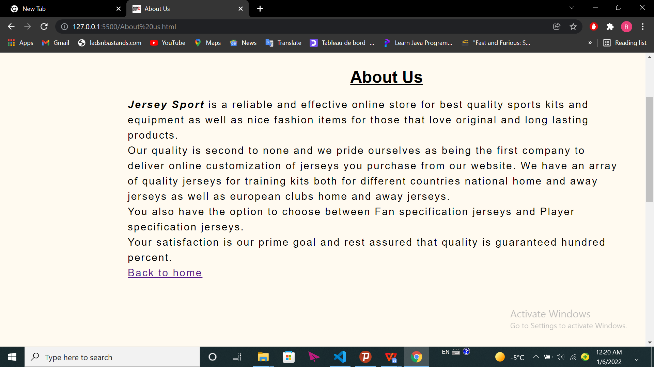

Fig9:The sample of About us page

# Analysis and Conclusions

In this section, you summarize your experience in the project. Be sure to answer the following questions (and be sure to answer with full sentences, do not

assume that someone reading your report has a copy of the questions):

• What were the goals or objectives of the project?

The Goals or Objectives of this project was to design and develop a webpage with the requirements I mentioned in the project specification like doing the link menu, a shop logo, a table used to display tabular data, login and registration (sign up) page and many more.

• Did you achieve these goals? Give specifics on how each was

accomplished.

According to the way I planned to do my project I can say that i am satisfied with how I did it therefore I achieved my goals starting from Designing and Developing a small Online Jersey Store that will be selling Jersey online where by my store had different kinds of Jersey as I had planned and in Developing I also achieved it from the first webpage which was the Home page and I managed to create a css file which helped in styling my webpage as I showed in the pictures above..

• Looking back on the project what would you do differently in the design

phase and in the coding and testing phases?

Looking back at the project what I would do differently is to make it more professional given enough time like adding maybe other features creating an animated page and put it online.

• What additions would you suggest to improve the working of your

program? This section usually counts for a large percentage of the grade,

so be precise and explain yourself fully. This is where we see what you

learned from the project.

In addition to make my website more efficient we can make our forms and website dynamic(using PHP language,Database…)so that we can save some people information, access to some pages by login and navigate inside our website in reel time.Even we can add some features like shipping or getting promo code for customers.